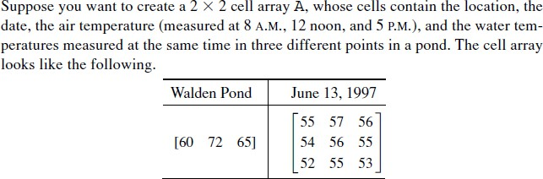

% change the value of the structure using field name

clear student % clear student

student(1) = struct('name', 'Banny', 'scores', [85,80,92,78]);

student(2) = struct('name', 'Joey', 'scores', [80,85,90,88]);

student(3) = struct('name', 'Betty', 'scores', [88,82,90,80]);

1. get the values of the scores of every students
2. Calculate the average score of each student by

Average score=0.2*score1+0.2*score2+0.3*score3+0.3*score4

1. Add a field name ‘avg’ for the Average score of the student.

Create a structure “student” with the field name and the data as follows:

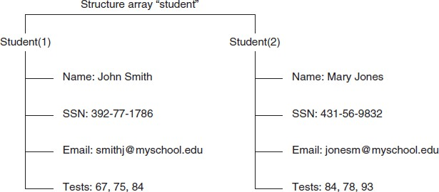

1. Read Excel file **test_score1.xls** with MATLAB in structure array.
2. Calculate the average scores with mean function.
3. Export table from MATLAB to an excel file.